BULLETIN NO. 230102
Technical Bulletin

DATE: 1-20-23

PRODUCT: Aluminum Condensing Boiler

FROM: Technical Service Department

TITLE: Control Board Plugs Switched

MODELS AFFECTED:

Utica UB90’s 75-200

SITUATION: Molex plug connections for the blower & circulator are switched on control board part # 14662803. This effects service parts only.

SOLUTION: If you have received a control board where the plugs are switched, please contact ECR customer service @ 1-800-228-9364 or ECR web portal to arrange a warranty return. We apologize for any inconvenience this may cause.

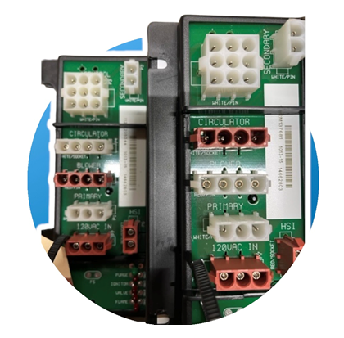
Incorrect Locations
Correct Locations

